Specification of modules

**The model simulates the financial results & cash flow of an investment in a solar power plant. The aim is to make the model stochastic using Monte Carlo approach. The variability of sun irradiation, technical reliability and variability of economic parameters will be taken into account.**

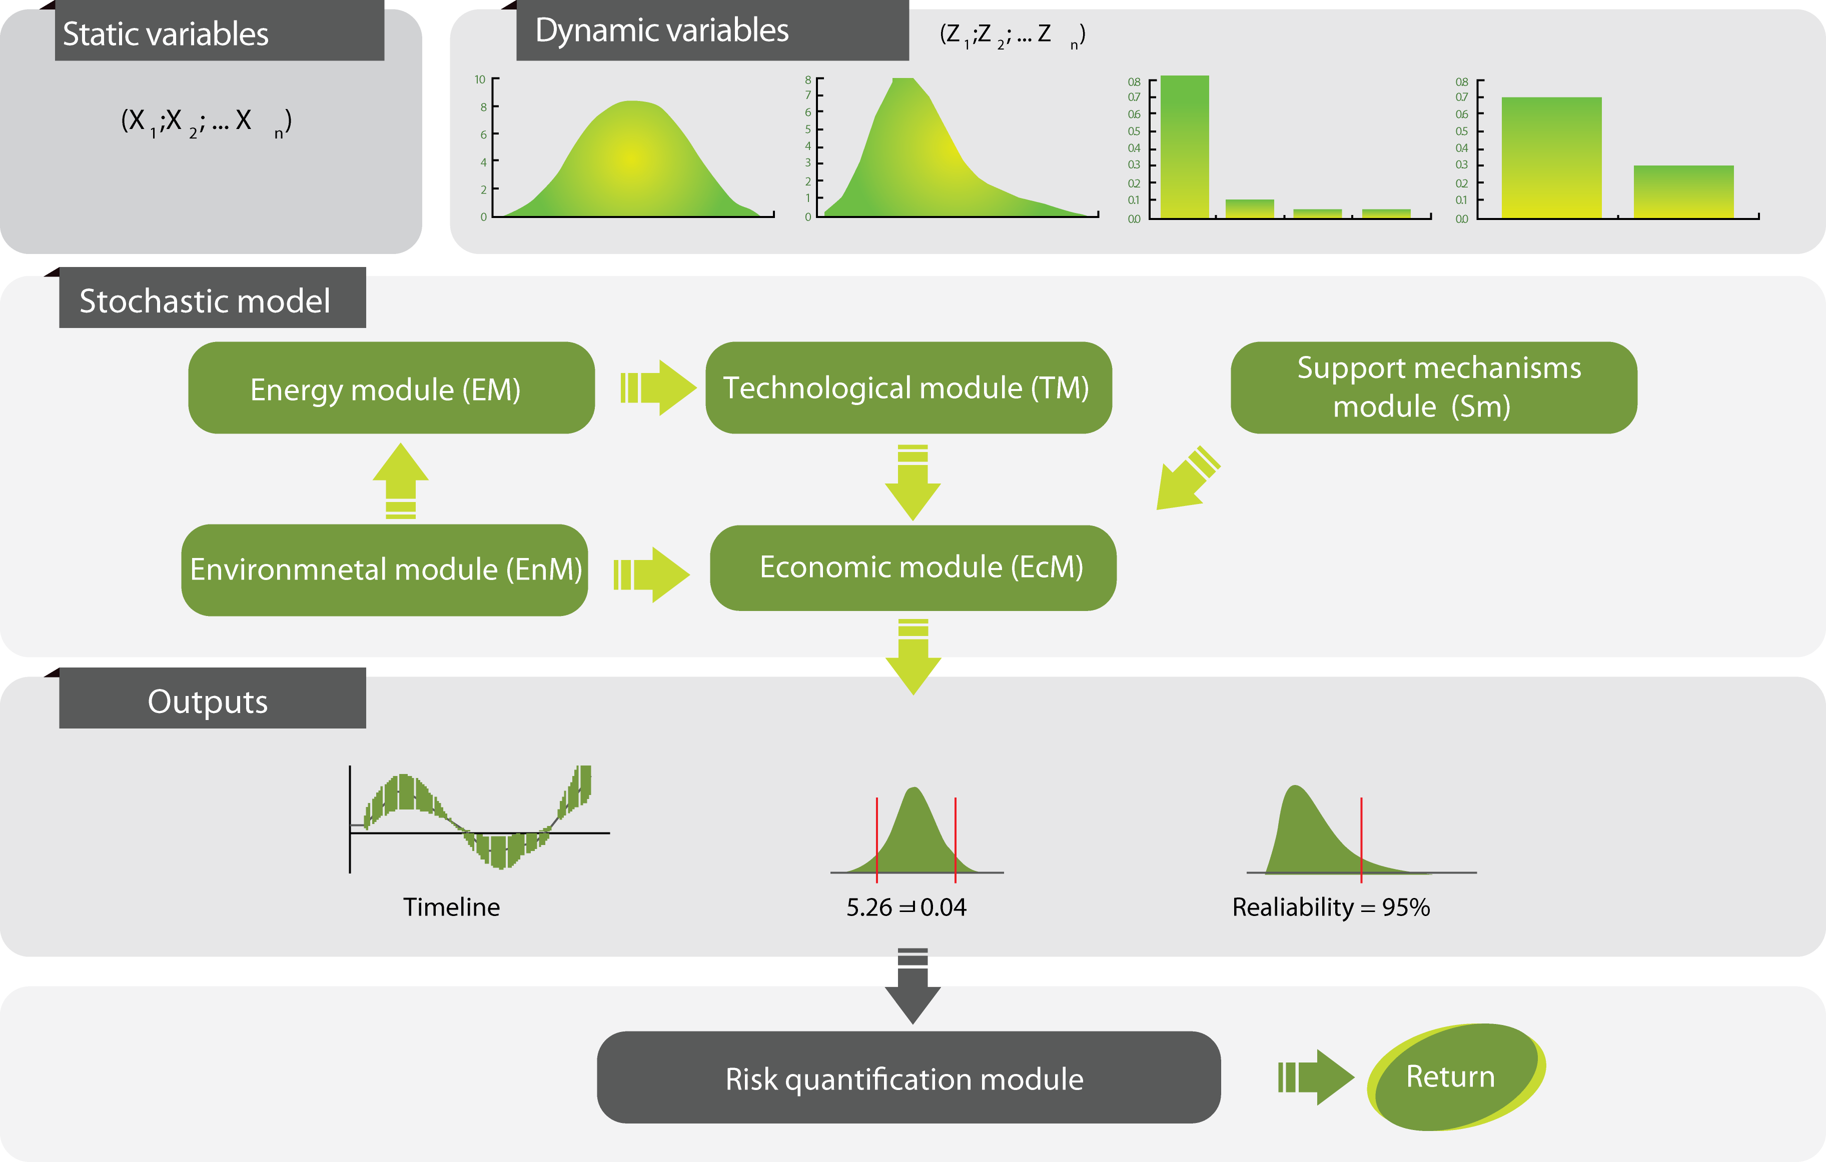

**Table of contents**

1 General functioning 3

2 Energy module (EM) 3

2.1 Module description 3

2.2 Key inputs 3

2.3 Outputs 4

2.4 Definition of functions 4

3 Technological module (TM) 4

3.1 Module description 4

3.2 Key inputs 4

3.3 Outputs 4

3.4 Definition of functions 4

4 Economic module (EcM) 5

4.1 Module description 5

4.2 Key inputs 5

4.3 Outputs 5

4.4 Definition of functions 5

5 Environmental module (EcM) 7

5.1 Module description 7

5.2 Key inputs 7

5.3 Outputs 7

5.4 Definition of functions 7

6 Support mechanism module (SM) 7

6.1 Module description 7

6.2 Key inputs 7

6.3 Outputs 7

6.4 Definition of functions 8

7 Risk quantification module (RM) 8

7.1 Module description 8

7.2 Key inputs 8

7.3 Outputs 9

7.4 Definition of functions 9

# General functioning of the model

The model functions in this sequence:

1. Inputs are entered using text files(s)
2. A loop is run X times/cycles (X is set in inputs):
   1. Based on inputs some values are randomly generated by running initModule for each module
   2. the expected cash flow is generated and written to a database by running EcM.generateISandBS
3. Results are displayed:
   1. RM. outputIRRHistogram
   2. RM. outputIRRXYGraph

# Energy module (EM)

## Module description

Takes care of:

* prediction of daily availability of primary energy

## Key inputs

|  |  |  |  |  |
| --- | --- | --- | --- | --- |
| N | Input | type | Source | Comment |
| 1 | monthly solar insulation | matrix – float | user inputs | averages for each month in the year |
| 2 | monthly average daily max T | matrix-float | user inputs | averages for each month in the year |
| 3 |  |  |  |  |

## Outputs

|  |  |  |  |  |
| --- | --- | --- | --- | --- |
| N | Output | type | To be used in | Comment |
| 1 | 30 years of daily solar insulation | matrix - float | TM |  |
| 2 |  |  |  |  |

## Definition of functions

### initModule

runs generatePrimaryEnergyAvaialbility

### generatePrimaryEnergyAvaialbility

Parameters:start date

based on data from database creates the prediction

for each day of month ..insulation = average monthly insulation * (random factor according to normal distribution)

# Technological module (TM)

## Module description

Takes care of:

1. conversion of primary energy into electricity

## Key inputs

|  |  |  |  |  |
| --- | --- | --- | --- | --- |
| N | Input | type | Source | Comment |
| 1 | 30 years of daily solar insulation | matrix - float | EM |  |
| 2 |  |  |  |  |

## Outputs

|  |  |  |  |  |
| --- | --- | --- | --- | --- |
| N | Output | type | To be used in | Comment |
| 1 | electricity in kWh for each day | matrix float |  |  |
| 2 |  |  |  |  |

## Definition of functions

### initModule

1. energyConversionFactor
2. Runs generateElectiricityProduction

### generateElectiricityProduction

based on insulation generates electricity production values fro each day

produced electricity = insulation * energyConversionFactor

### getElectricityProduction

Parameters: dateStart, dateEnd

gives the sum of the electricity produced in the specified period

getElectiricityProduction = sum of electricity in kWh for each day for the selected period

# Economic module (EcM)

## Module description

Calculates a series of monthly cash flows

## Key inputs

|  |  |  |  |  |
| --- | --- | --- | --- | --- |
| N | Input | type | Source | Comment |
| 1 | electricity market price | float | user input |  |
| 2 | expected growth of electricity prices | float | user input |  |
| 3 | amounts of investment | float | user input |  |
|  |  |  |  |  |
|  |  |  |  |  |

## Outputs

|  |  |  |  |  |
| --- | --- | --- | --- | --- |
| N | Output | type | To be used in | Comment |
| 1 | IS&BS for 30x12 months | matrix | RM |  |
| 2 | IS&BS cash flow for 30 years | matrix | RM |  |

**See: IS & BS. xlsx**

## Definition of functions

### initModule

### getRevenue

parameters: dateStart; dateEnd

E:= getElectiricityProduction;

sum for all days in the period: E * price + subsidies (E; date)

### getCosts

parameters: dateStart; dateEnd

sum of costs for all days in teh period = num of days * costs per month/30

### calculateTaxes

EBT in the year * 20%

enetered only in december

### getDebtPayment

parameters: dateStart; dateEnd,.....

calculate the payment of the debt principal based on constant annuity repayment - http://en.wikipedia.org/wiki/Fixed_rate_mortgage

### calculateInterests

((debt in previous period + debt in current period) /2) * interest rate * num of days/365

### calculateFCF

calculates the free cash flow based on IS nad BS

= net earnings + amortisation – investments in long term assests

### generateISandBS

parameters: dateStart; dateEnd

1. generate monthly IS (Income Statements (IS) and BS (Balance Sheet))
2. fill in revenues by running getRevenues for each month
3. fill in costs by running getCosts for each month
4. fill in start positions for assets
5. fill in start position of equity and debt (equity = 30% of investment; longterm debt = 70% of investment)
6. fill in loan by running getDebtRepayment for each period and decrease the debt for the specified amount
7. fill in depreciation by running getDepreciation for each month
8. fill in interest by running calculateInterests
9. calculate EBIT, EBT (earnings before taxes)
10. calculate taxes by running calculateTaxes
11. calculate net income
12. update the balance sheet (with net income, depreciation etc.)
13. if funds in a period are missing – increase short term loans; if excess cash, decrease short term loans

### calculateReturn

calculates IRR and writes it to the database

inputs are the monthly free cash flows (FCF) for the whole project

# Environmental module (EcM) – for now does nothing

## Module description

1. Sets limits to production due to environment protection factors (e.g. for hydro – sets biological minimum)
2. Calculates the obligation at the end of the projetc (e.g. cost of disposal)

## Key inputs

|  |  |  |  |  |
| --- | --- | --- | --- | --- |
| N | Input | type | Source | Comment |
| 1 | cost of disposal per kW installed power |  |  |  |
| 2 |  |  |  |  |

## Outputs

|  |  |  |  |  |
| --- | --- | --- | --- | --- |
| N | Output | type | To be used in | Comment |
| 1 |  |  |  |  |
| 2 |  |  |  |  |

## Definition of functions

### initModule

# Support mechanism module (SM)

## Module description

Takes care of:

1. defining the amount of subsidy for investment
2. defining the amount of subsidy for production
3. definition of tax relief/subsidy

## Key inputs

|  |  |  |  |  |
| --- | --- | --- | --- | --- |
| N | Input | type | Source | Comment |
| 1 | country | text | user input | used to define the subsidy system |
| 2 | amounts of investment | float | user input |  |
| 3 | amount of subsidy per kWh | float | user input |  |
| 4 |  |  |  |  |

## Outputs

|  |  |  |  |  |
| --- | --- | --- | --- | --- |
| N | Output | type | To be used in | Comment |
| 1 | amount of subsidy for investment | float | economic module |  |
| 2 | amount of subsidy for energy | float |  | for now juts equals to the input – later on should be retrieved from a database based on country |

## Definition of functions

### initModule

sets values for:

1. dateStartOfSubsidy (set to day 1 of the project)
2. dateEndOfSubsidy (set to 12 years after start of the project)
3. susbsidyPerKWh (reading from inputs)

### subsidyInvestment

Input parameters:

1. investment type (land, equipment)
2. amount of investment in EUR
3. nominal installed power in kW

Output: amount of subsidy = 0

### subsidyProduction

Input parameters: energy, date

Output: amount of subsidy = if date < dateEndOfSubsidy then energy * subsidy/kWh else 0.

### subsidyTax

Input parameters:

Output: amount of tax decrease = 0

# Risk quantification module (RM)

## Module description

Takes care of:

* calculates the variability of return
* calculates VaR of internal rate of return
* calculates the average rate of return

## Key inputs

|  |  |  |  |  |
| --- | --- | --- | --- | --- |
| N | Input | type | Source | Comment |
| 1 | multiple series of cash flows for 30x12 months + returns |  | EM |  |
|  |  |  |  |  |
|  |  |  |  |  |

## Outputs

|  |  |  |  |  |
| --- | --- | --- | --- | --- |
| N | Output | type | To be used in | Comment |
| 1 | variability of return | histogram - table |  |  |
| 2. | average rate of return |  |  |  |

## Definition of functions

### initModule

### outputIRRHistogram

outputs histogram of IRR values into a jpg or other format

### outputIRRXYchart

outputs XY chart of Y = IRR values for each cycle and X = consecutive number of the cycle